Vibox Serial Connection

To establish a serial connection, the following “usb to serial adapter” can be used.
Example:
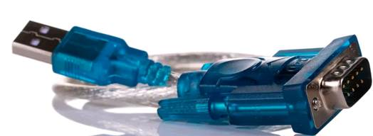

The above cable has a subD9 on one side. The following image shows the Pin Layout of the RS232.
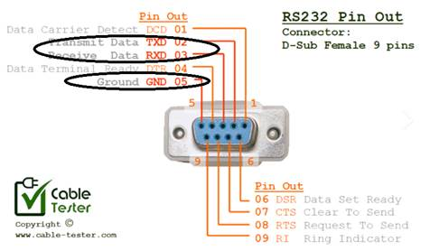

And a M12 8 pin connector having the pin1 and 2 connected and ground (pin5)
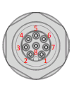

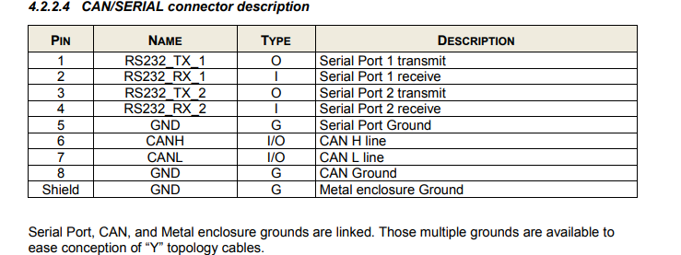

Once the connections are established through the CAN/Serial Port as per the above information. To access the Vibox now, the following steps must be followed:

Software Used:Putty
Mode of connection: Serial
Serial Line: COM port of the laptop where the USB is connected.
SPEED: 115200

Example when using a COM8 Port.
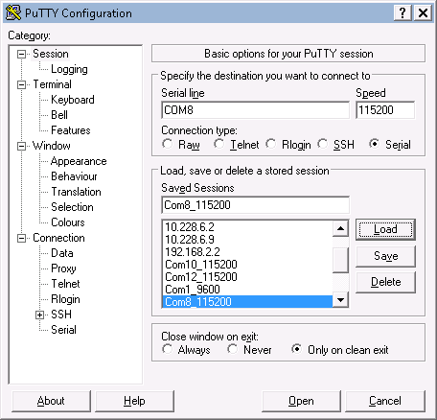

For the above, to know which port to use, check the device Manager >> Ports (COM & LPT)