Vib360 software License Activation in Vibox

- Connect the Vibox (default IP is 192.168.0.10) to a PC (the PC need to be set to be n the same mask, for exemple 192.168.0.100)
- Having Vibacq installed on the PC
- Check that Vibacq will run in a “debug” mode:
Edit the file C:\Program Files (x86)\Vib360\AcquiVibox\Acqui.ini and make sure the adminMode is 1:
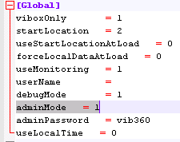
- Start Vibacq
- Click on Config button
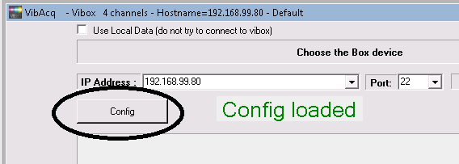

- Click on Install button
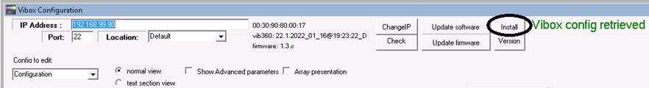
- Select the InstallVib360.tar.gz file of the vib360 package:
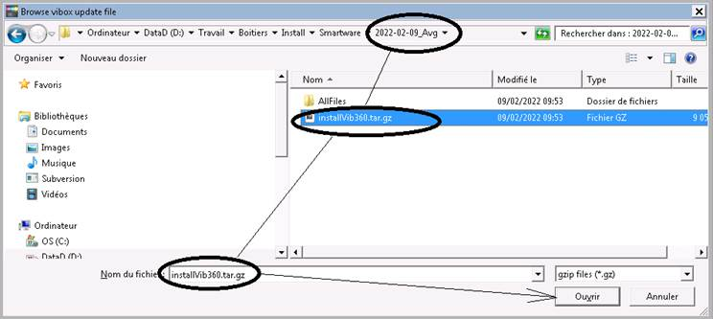
And click on “Open”. Will take a couple of seconds

- Select the SmartwareInstallVib360.sh file of the vib360 package:
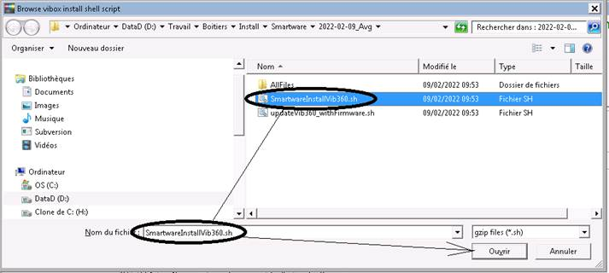
Clik on “Open”
- After a couple of second you will see something like that:

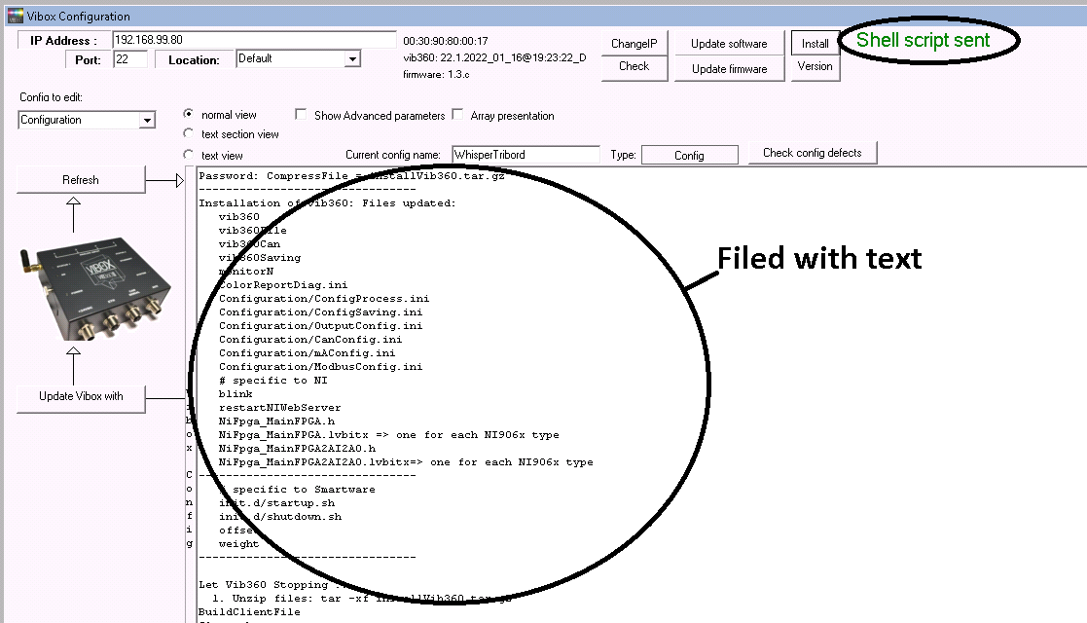

- Reboot the Vibox:
- 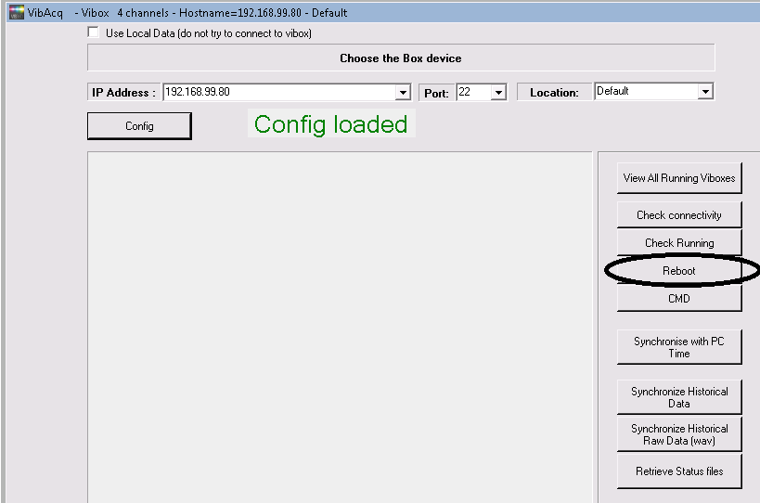
- Wait around 30 seconds, then go back to the config:
- 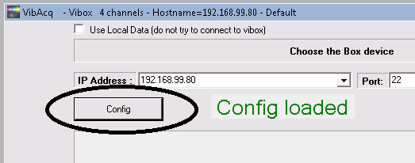
- And check the firmware version :
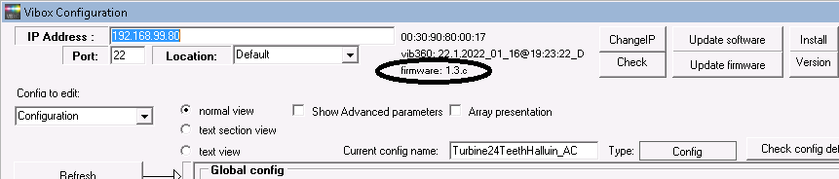
  - If it does not say 1.3.C (for exemple 1.3.b) then we need to update it:
  - Click on update firmware button
  - Select the file as done before:
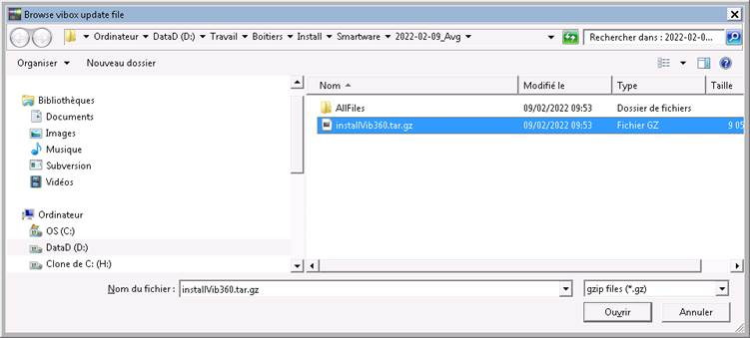
  - But now Select the second shell script named : updateVib360_withFirmware.sh => this will update the vibox with the firmware 1.3.c
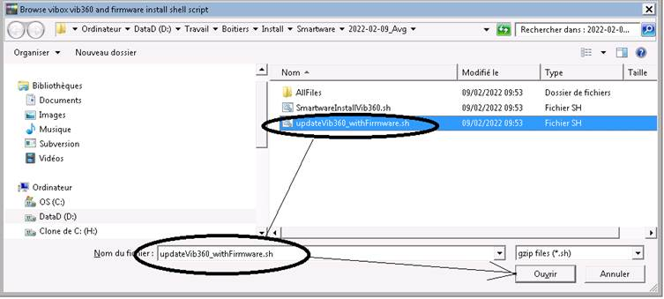
  - Reboot the Vibox
- Open a ssh connection and send me the file named /home/impedance/client
…
- I will send you back a file named tdc that you will have to copy into /home/impedance/
…

- You can now check that the vibox is behaving correctly. The easiest way is to use a configuration with a bearing module in it and having the minVolt at 0.0001 and let the system running. You should view some result after 1 minute. If it says status -6 it means that the licence is not there if it says -8 it means that the level or speed is too low
- Exemple of a bearing configuration on the 4 channels( 4 transducers, and 4 bearing diagnostics: ch1 à ch4 , length of minimum of 4 s, MinVolt=0.0001
- 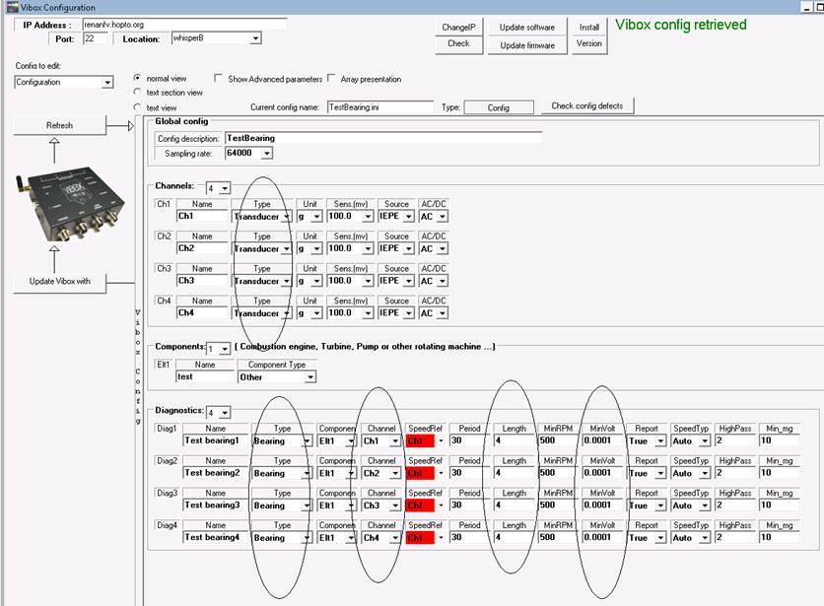
- You can use the configuration file attached
  - Copy it into C:\Program Files (x86)\Vib360\AcquiVibox\configs\configProcess
  - Open Vibacq and go to the config (menu hardware, button config) , select the testBearing.ini config and send it to the Vibox
1.Select testBearing.ini 2. Click on View 3; click on Update Vibox With
