Vib360 software update in vibox using vibacq

Purpose of the document

The present document explain the procedure to update the embedded Vibox from Vibacq and a installation package “installVib360.tar.gz”

Update the embeded box « Vibox » using Vibacq
Prerequisite:
- PC with Vibacq software installaed
- The Vibox to update connected to the PC via an ethernet/internet connection

- Start Vibacq
- Check that you are “Admin” you should see “AdminMode” in the third menu:
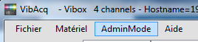
  - If not click on “UserMode” menu and hit “vib360” as password
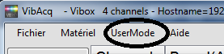
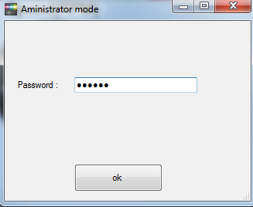
  - click OK and we are now in “AdminMode”:

- click on the « Hardware » menu
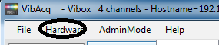
  - click on the « Config » button
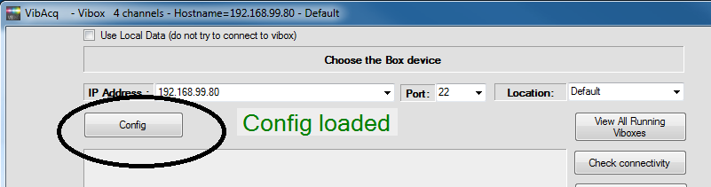
- Click on « UpdateSoftware » button:
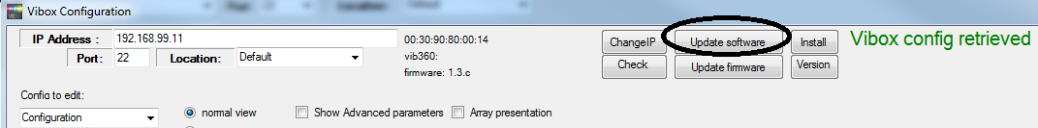
- Browse to the directory where the package installVib360.tar.gz is located. Exemple:
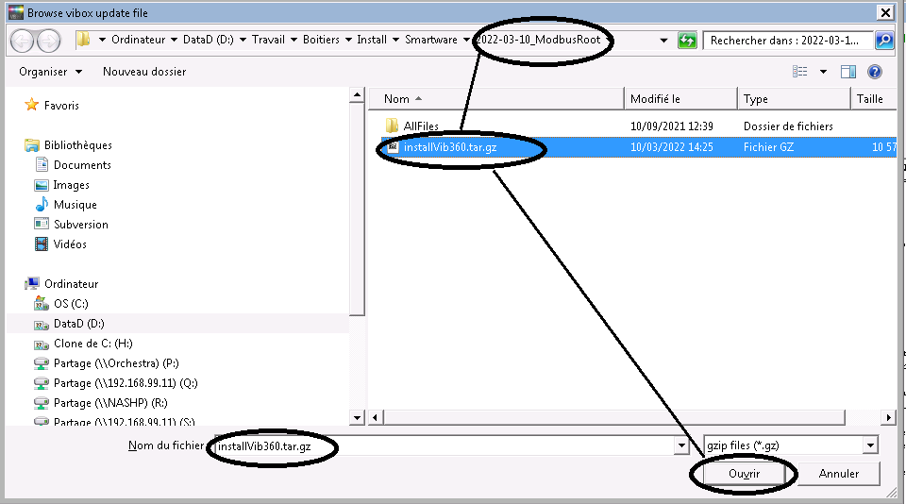
- Select the file and click on the « Open » button. After a couple of seconds you should see the following message « Update Sent » appearing in green in the upper left of the screen:
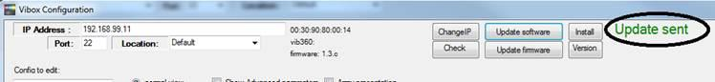
- After around 1 minutes the Vibox will be updated

VérifY the Vibox Mac adress
Prerequisite:
- PC with Vibacq software installaed
- The Vibox to update connected to the PC via an ethernet/internet connection

- Brancher le PC à la Vibox
- Démarrer Vibacq
  - Click on menu « Hardware » :
  - Select the correct IP of the Vibox (for exemple 192.168.99.11)

  - The MAC adress and vesion is visible there :
