Torque Module
In house testing report

The document explains the general testing mechanism and details on the tests performed for IAC Vikrant Trial on 23-01-2023. The general testing process before dispatching to any site is segmented into the following:

- Vibox:
 | Test Condition | Test Status
Power | Check whether the Vibox is able to take 24V DC. Stable 24V DC must be provided to the Vibox using an SMPS | ✔
System | Check if the system LED is Green after the 24V DC power is supplied. | ✔
Status | Check if the Status LED is Green when the sensors are connected to the Vibox. | ✔
SD Card | Check if there’s an SD Card & the SD LED is Green | ✔
Ethernet | Check if the ethernet LED is Green when connected to the laptop in the same network. | ✔
Run check | Keep the vibox running for a couple of hours to make sure the vibox is working well. | ✔
Firmware Version | Latest firmware version :1.3.c | ✔
Software Version | Check if the working version of Vib360 software is being used | ✔

- Vib360:
- The software version used inside the Vibox must be checked for the expected results.
- Process1: using a set of .dat file of previously collected data and the suitable configuration
In the case of Torque module testing using a .dat file, the following files are used:
- .dat file
- Configuration file
- vibTorqTest - an executable file to run the .dat file for auto calculation of Torque
Ex: ./vibTorqTest Configuration/ConfigProcess.ini 0 Data/PROCESS1/<FILENAME>.dat
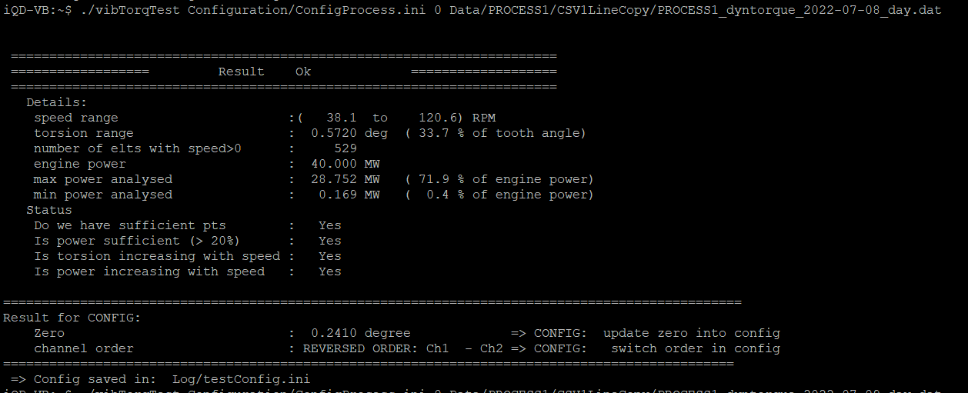
- Process2: using a set of .wav files of previously collected data and the suitable configuration.
In the case of Torque module testing using a .wav file, the following files are used:
- .wav file
- Configuration file
- vib360File - an executable to run the .wav files for Vib360 analysis
Executable to be used: ./vib360File /home/impedance/Data/PROCESS1/WAVbuffer/ConfigProcess.ini 0 home/impedance/Data/PROCESS1/WAVbuffer/PROCESS1_2022-07-07-21h55m00_1RPM_Status_OK2.wav
A bundle of .wav files must be sent in the similar way to check the precision and consistency of results. As the data is from previously collected data, we can observe the results before & after the version update.
A sample test report is saved here

- Vibacq:
 | Test Condition | Test Status
Connection - IP address | Check connection of Vibacq with the Vibox by accessing the IP address of the Vibox | ✔
Dashboard | - Display of results with the right set of parameters  - Scales on the Gauges & Trends must be auto adjusted. | ✔  ✔
Configuration | Check if upload/ retrieval of configuration is seamlessly possible. | ✔
Software Version | Check if the working version of Vibacq software without any bugs is being used | ✔
Vibacq is used to update the software or firmware in the Vibox.

