SD Card Installation in Vibox

STEP 1: SD Card to be inserted inside the Vibox. POWER OFF THE VIBOX.

STEP 2: SD Card slot can be opened by unlocking the screw.
STEP 3: Insert the SD card in Vibox as shown.

STEP 4: Click on tip of SD to insert properly. Click on tip twice to remove in case.
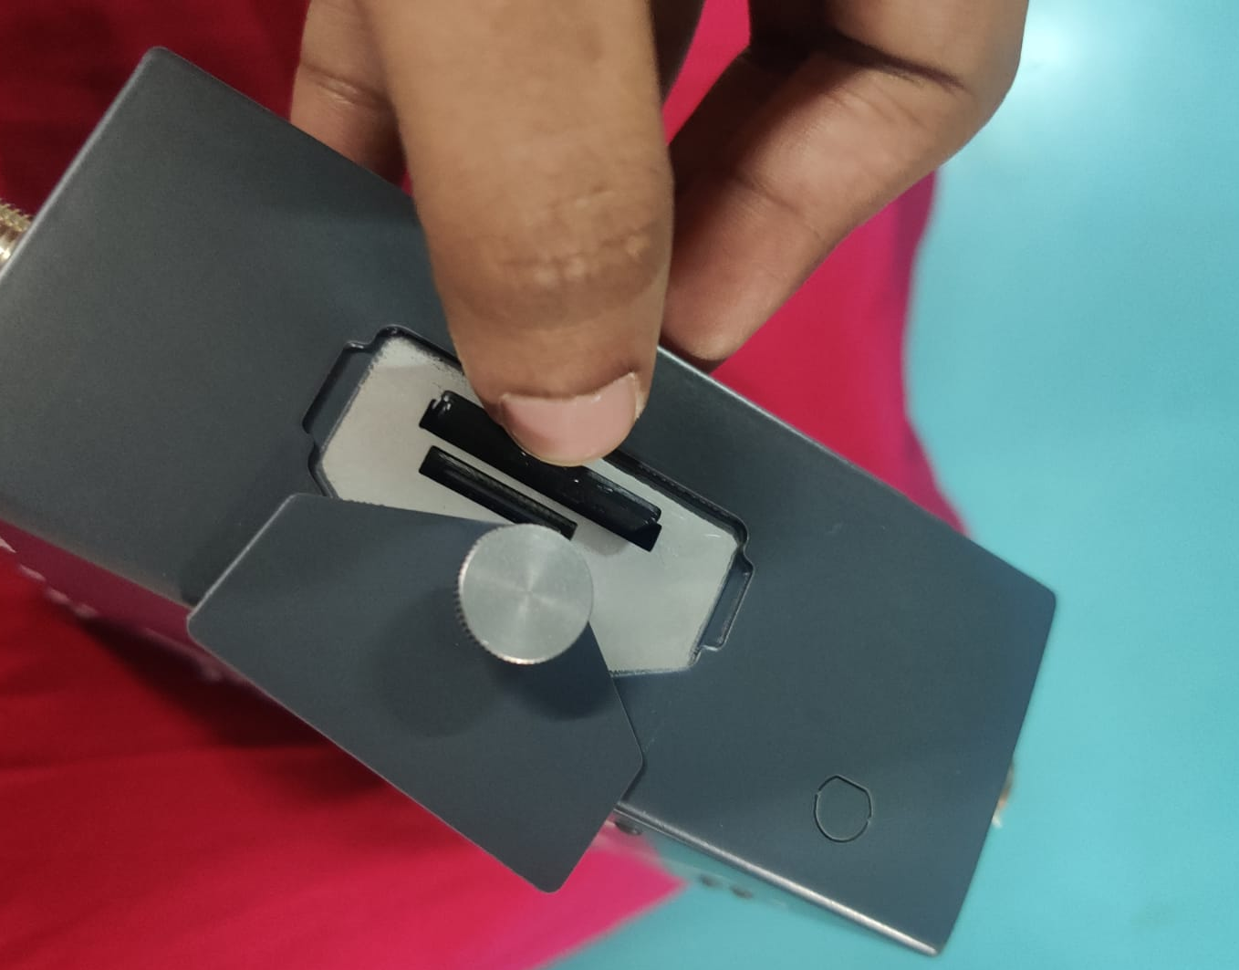
STEP 5: Tight the screw and lock the SD slot.
STEP 6: POWER On the VIBOX and check the SD Card LED ON.
